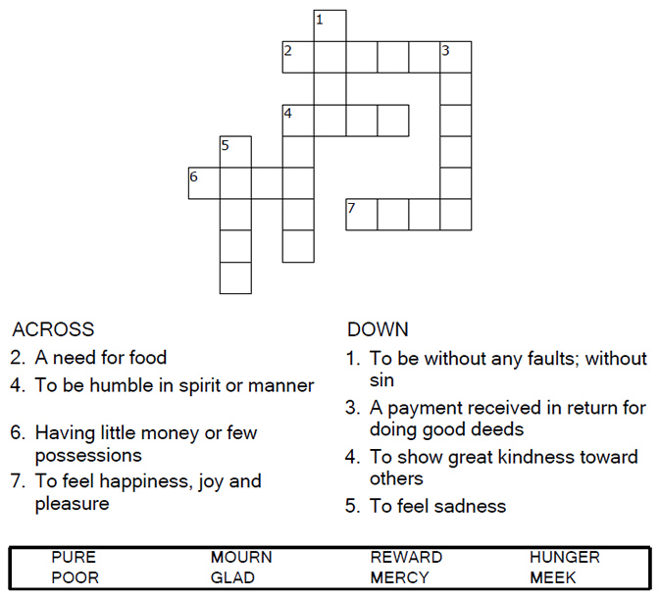

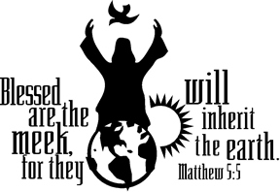

Copyright © Sermons4Kids, Inc.
May be reproduced for Ministry Use

Children’s Worship Bulletin

The Beatitudes

Matthew 5:1-12

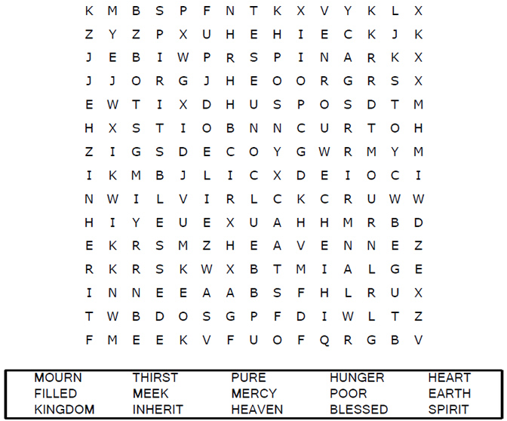

Each number represents a letter of the alphabet. Substitute
correct letter for the numbers to reveal the coded words.
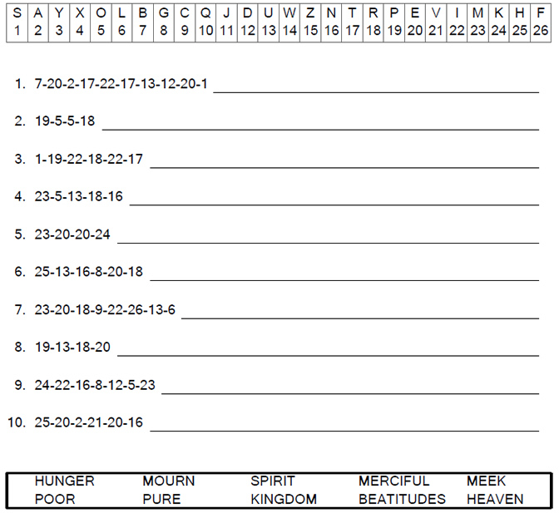
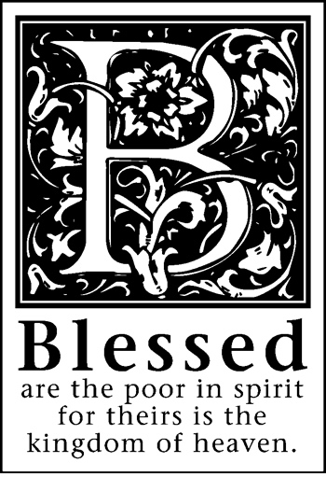

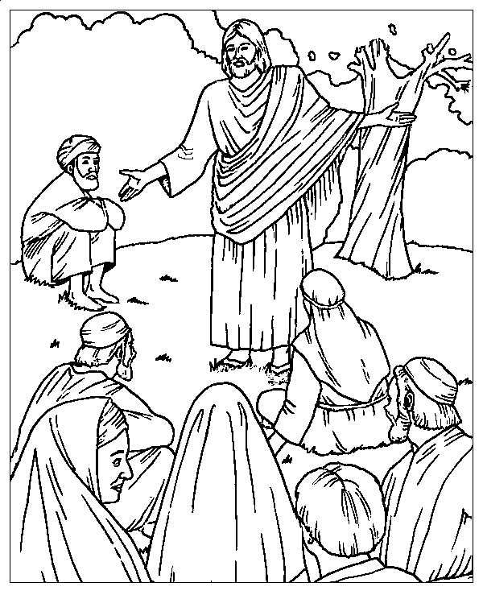
The Sermon on the Mount
Matthew 5:1-12

From BibleStoryCard Learning System(tm) Coloring Book © 1996 Wesleyan
Publishing House. Used by permission. Additional BibleStoryCard resources
are available by calling 1-800-493-7539 or visiting online
http://www.wesleyan.org/941/biblestorycards

